This process guide has been prepared by our team of Practitioner Support Officers. If you have any access issues, or for any reason wish to contact Victoria Legal Aid about content on this page, please contact grantstraining@vla.vic.gov.au.

Reconsideration requests
Reconsideration requests should be submitted when you disagree with a decision VLA has made and believe there are grounds for the decision to be re-assessed. This includes refusal decisions and a decision to impose a contribution or equitable charge on the grant.

Steps:
- Click on the reconsideration option from the left-hand menu under Applications.
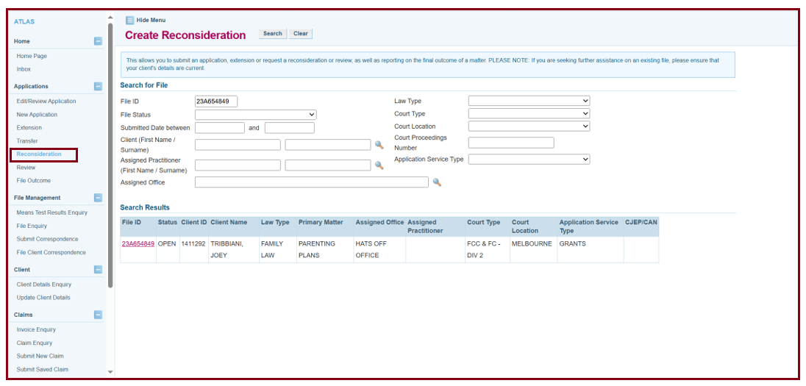
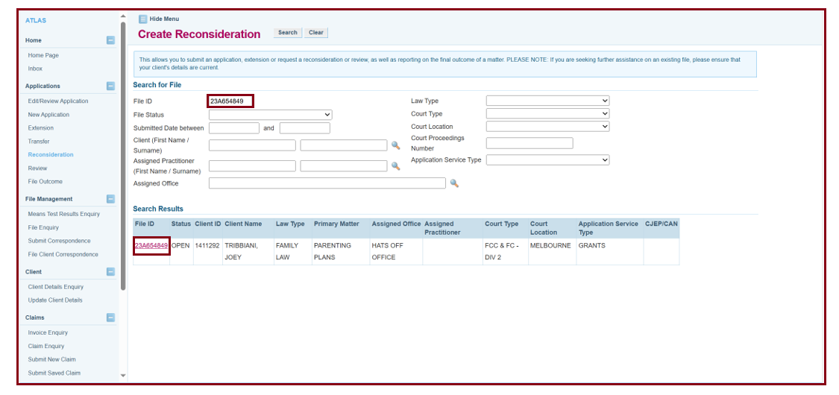

- Search using the file ID for the matter. Enter the file ID and select Search, then click on the file ID in the search results.
- In the extension box, you will need to enter the relevant extension you are seeking the reconsideration on. If it is the initial decision, then the extension will be 0
- Select the grounds for which you are seeking the decision to be reconsidered. If the option is not here, then select Other and provide your reasons.
- Click Next.

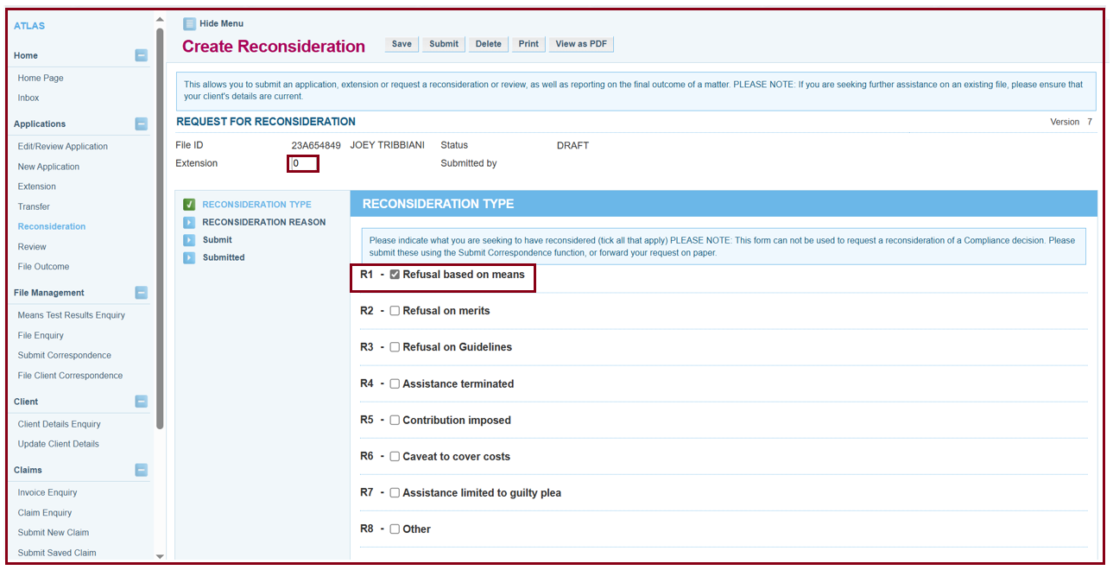
- Complete the text box. Provide reasons for your request. Ensure that you provide adequate information in the text box. If you do not have sufficient space to detail your reasons or wish to provide supporting documentation, you can select Yes under Attachment.
- Click next.
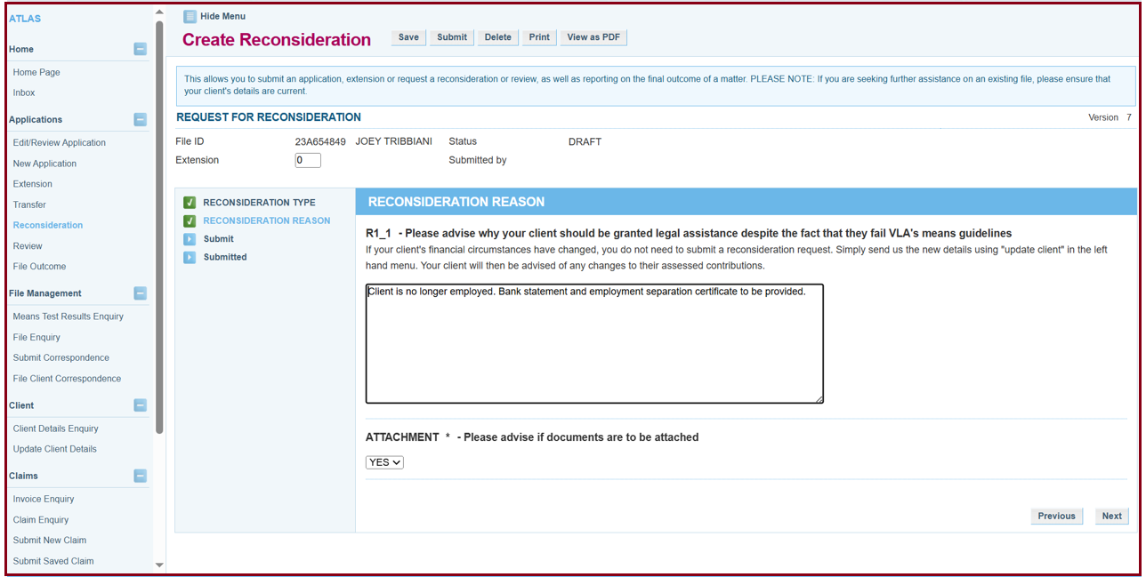
- Click the submit button.
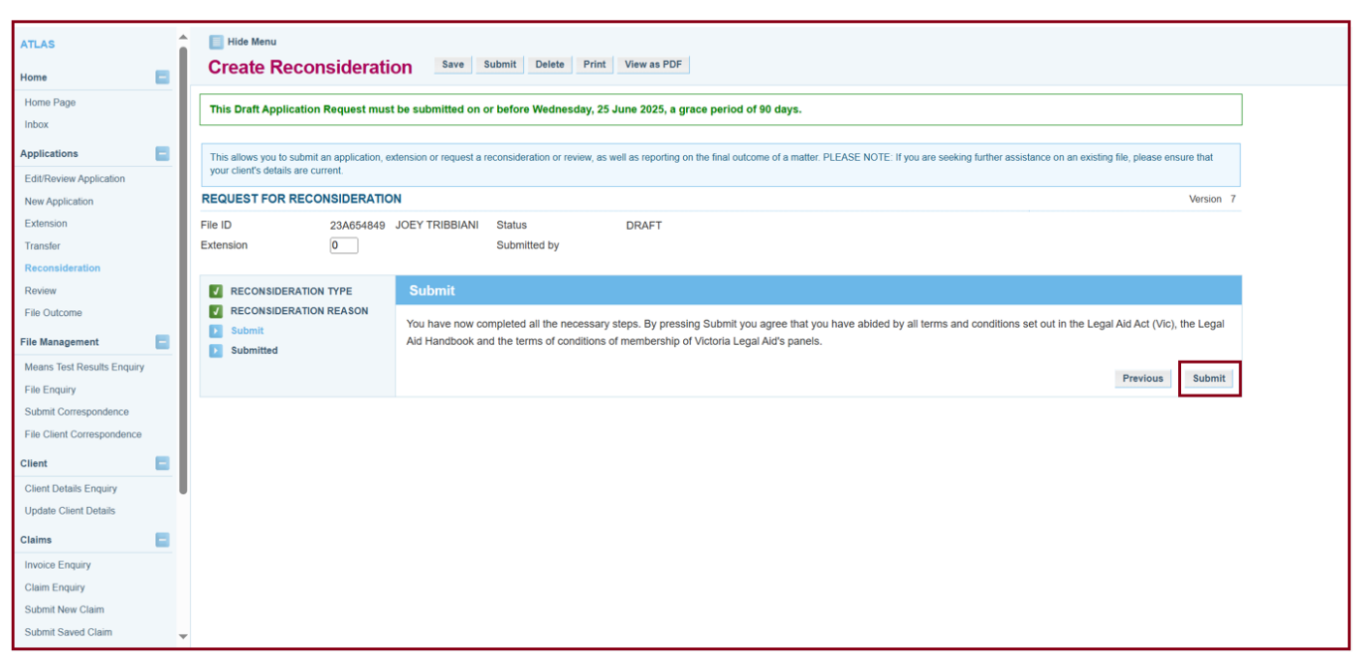\

Additional Information:
- Not all decisions regarding the provision of legal assistance can be reconsidered. The decisions that can be reconsidered include:
  - refusals of a grant or extent of assistance
  - conditions on a grant
  - changes to a condition of a grant
  - decisions to terminate or change a grant.
- Time limits -14 days from decision for reconsideration, if more than 14 days you will need to provide a reason it is a late request.

