This process guide has been prepared by our team of Practitioner Support Officers. If you have any access issues, or for any reason wish to contact Victoria Legal Aid about content on this page, please contact grantstraining@vla.vic.gov.au.

Submit a new application
Practitioners are required to submit all applications for legal assistance electronically using ATLAS.

Steps:
- Select New Application from the left-hand menu, under Applications.

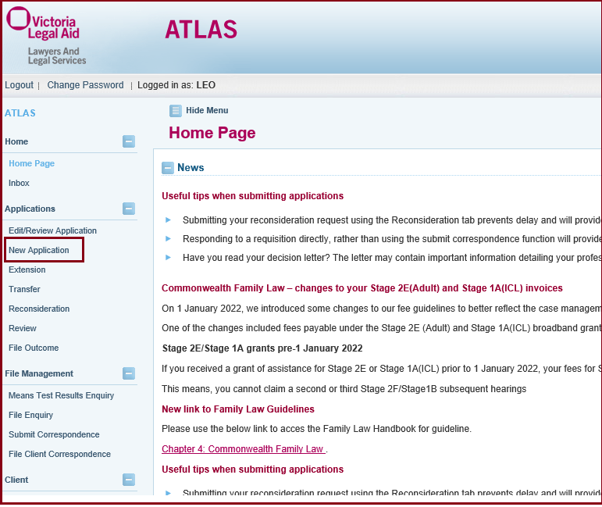
- Select Law Type to find the appropriate template for your matter.
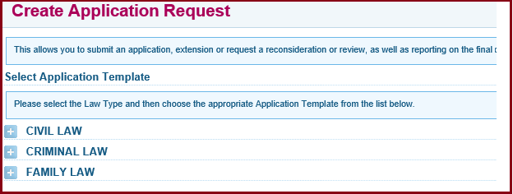
- Select the Application Template required under each law type.
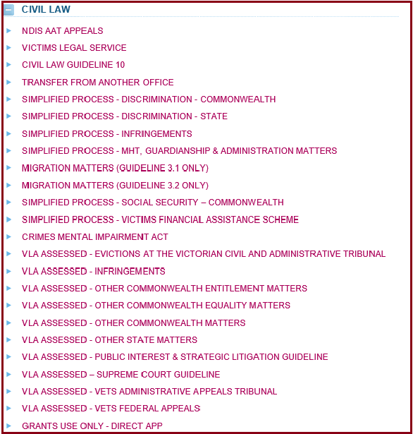
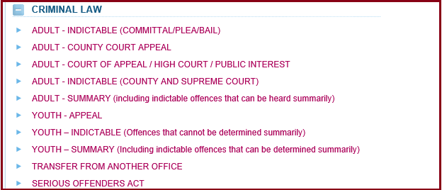
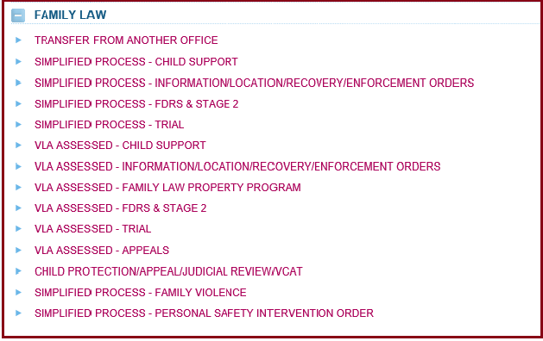
- Select the Application Template Required
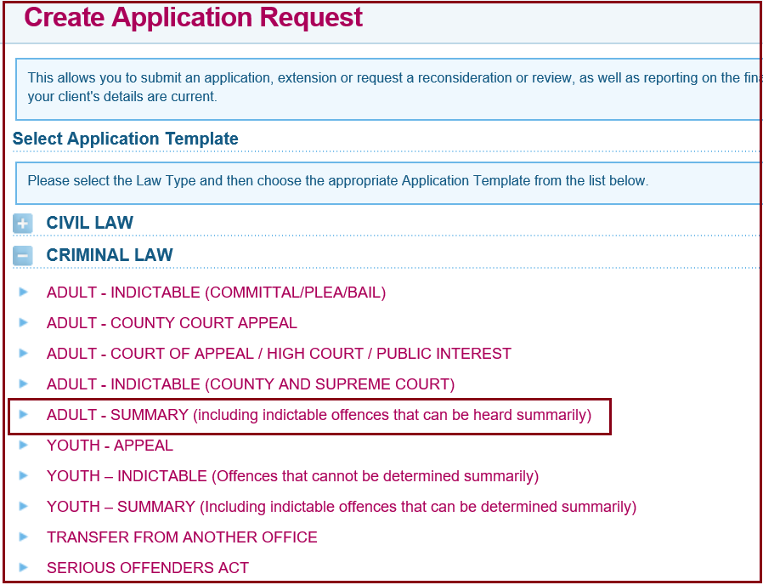
- The Search for Client screen will appear, enter the client’s details and click Search. Only names of current clients belonging to your firm will appear. Past clients will not be displayed.
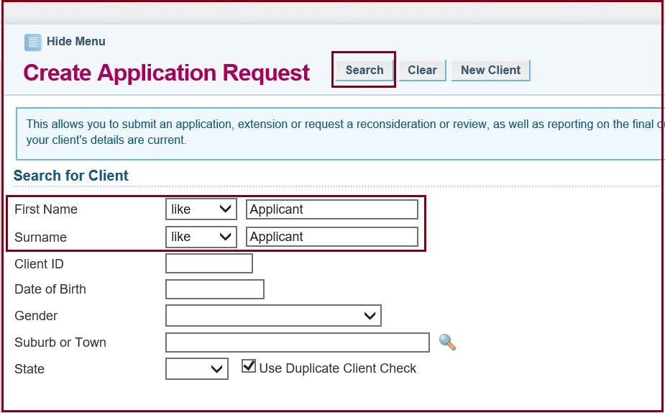
- If no record is found, you will need to create a new client in ATLAS.

- Select New Client at the top of the screen.
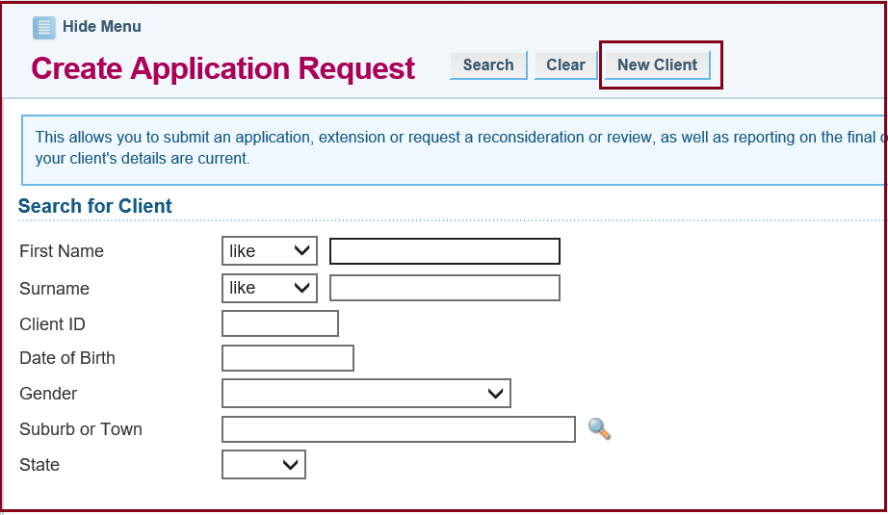
- An application form is displayed. A File ID is automatically assigned to the application. Use this number to retrieve and track the application. This file number will not be saved if the application is cancelled. The application remains in Draft Status until it is submitted.
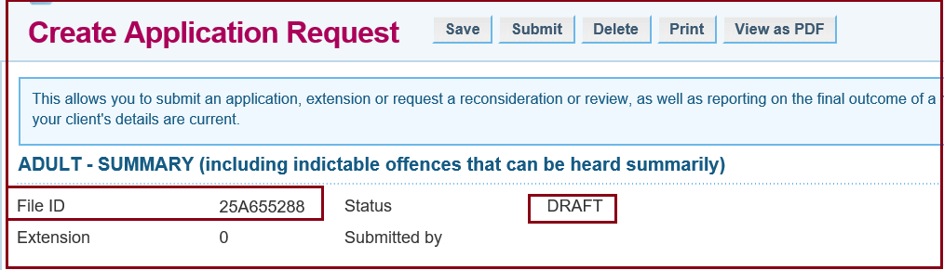
- Complete the relevant fields across the screen under Applicants Details. Use the blue arrow to navigate through the Applicant details tabs.
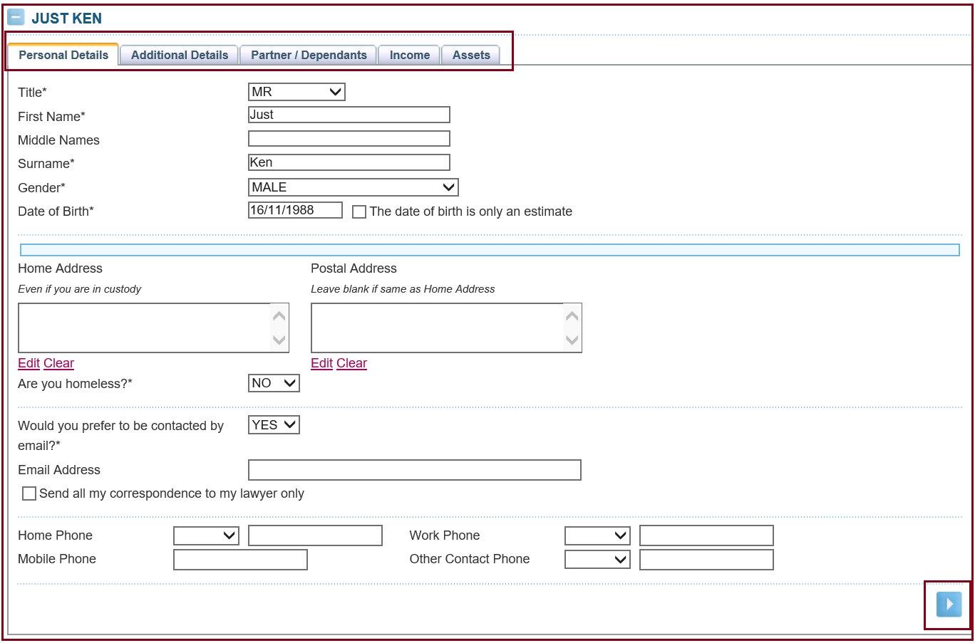
- To enter or edit an address, click Edit.
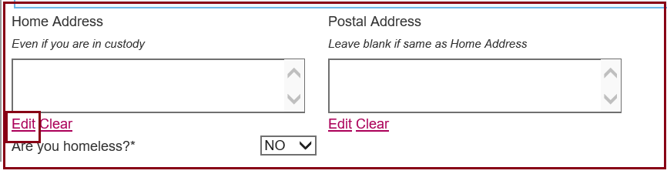
- Select the appropriate address format and street type from the drop-down lists. Enter the suburb and postcode. If you do not know it, click on the pick list (magnifying glass icon). The Select a Suburb/Town search screen displays. Enter the suburb and click Search. Click on the correct option to continue.
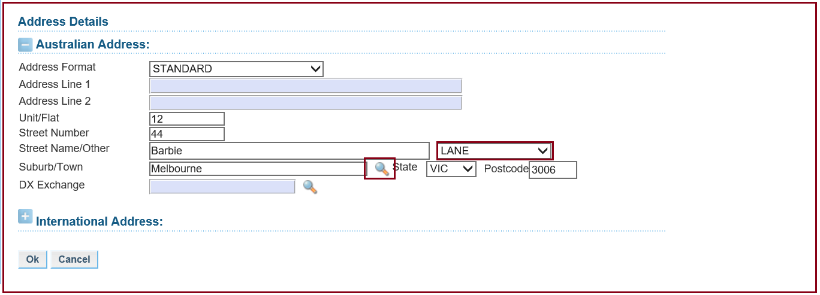
- Applications can be partially completed, and the Draft can be saved at any time by selecting Save at the top of the screen. A message at the top of screen will confirm the draft application has been saved successfully. If you need to leave the application and come back, click Edit/Review Application and insert the File ID into the search screen.
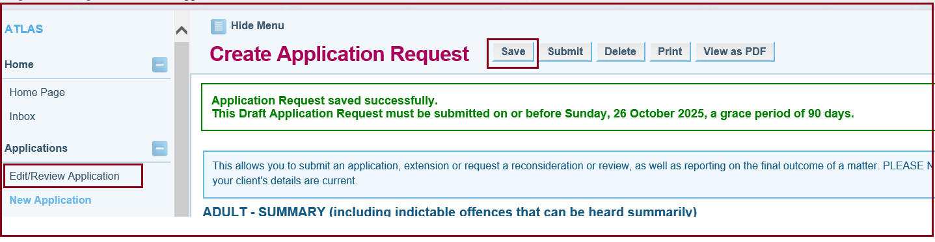
- It is important to say whether there are any influencing factors. This is mainly for our internal data so that we can better understand the clients we assist with a grant of aid. If your client is a family violence victim/survivor, there is an exemption to signing an equitable charge over property they have declared. You can let us know whether your client is experiencing family violence by selecting ‘FV - VICTIM/SURVIVOR’ as the influencing factor.
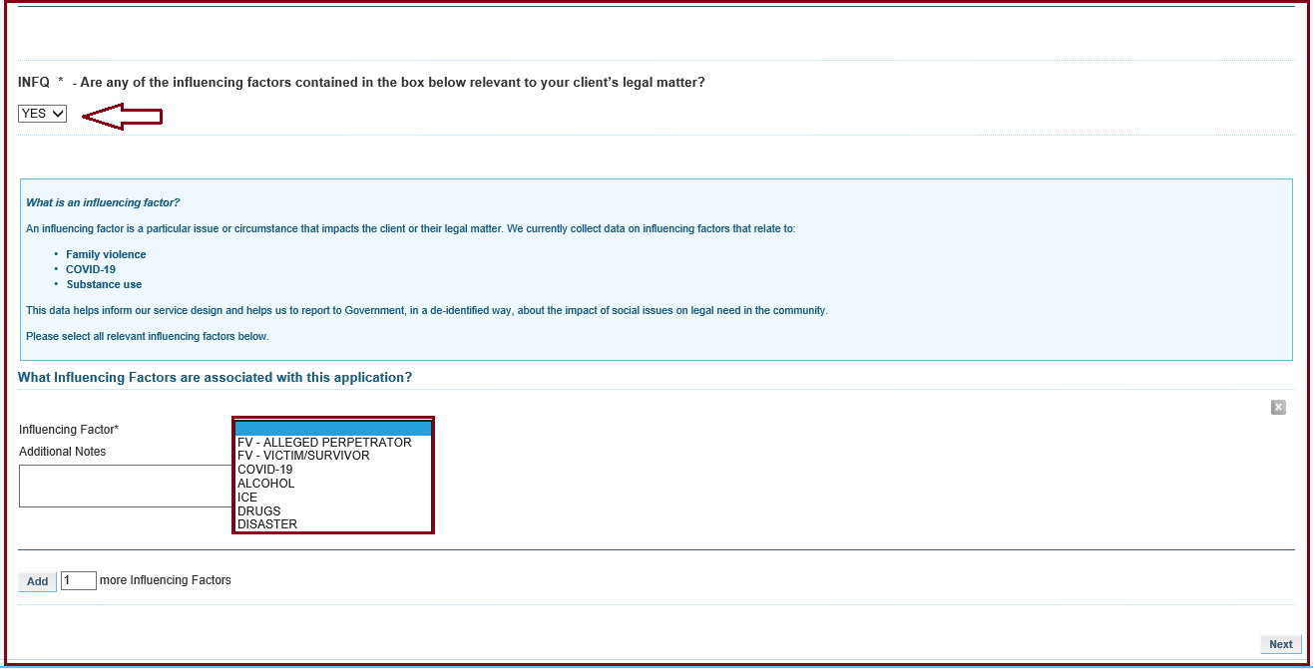
- The next section in Applicant Details is the Additional Details tab. If your client requires an interpreter, then select Yes and this disbursement will automatically be inserted. If your client is working and receiving benefits, then it is important to select no, that Centrelink is not the only source of income. Lastly, it is important that you let us know if your client is in custody.
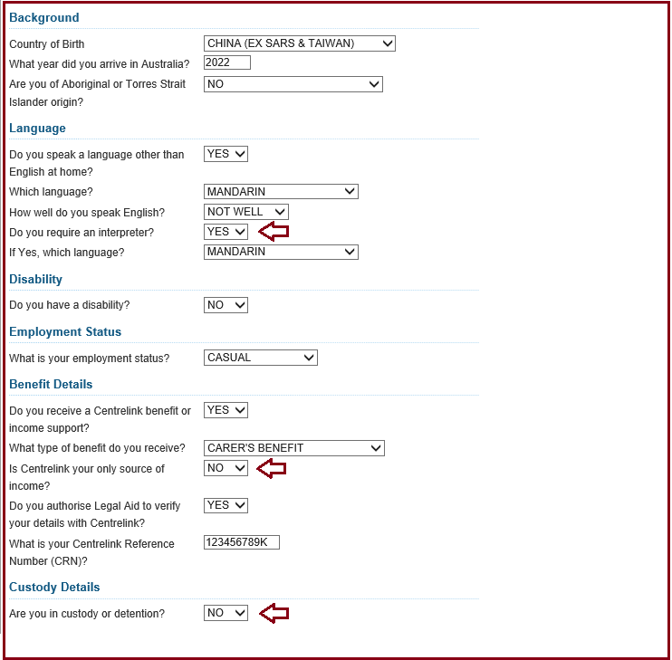
- The Partner/Dependents Tab is next. If your client has a partner, then their income and assets may have to be included. It is important to list any dependents as they are considered as allowable expenses. Any child support or maintenance paid is also considered as an allowable expense. For further information about this, please see section 12 of the VLA Handbook.
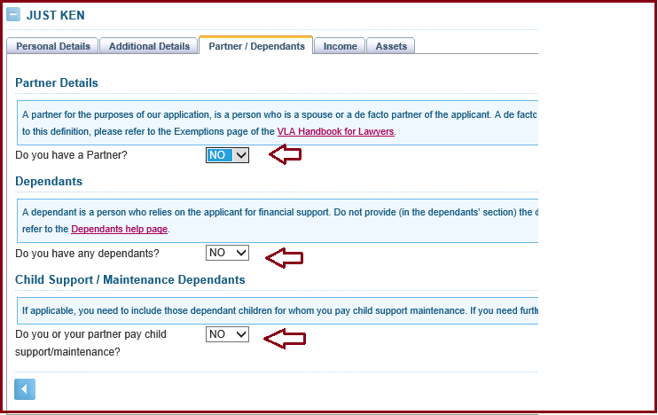
- The last two sections in the Applicant Details are Income and Assets.
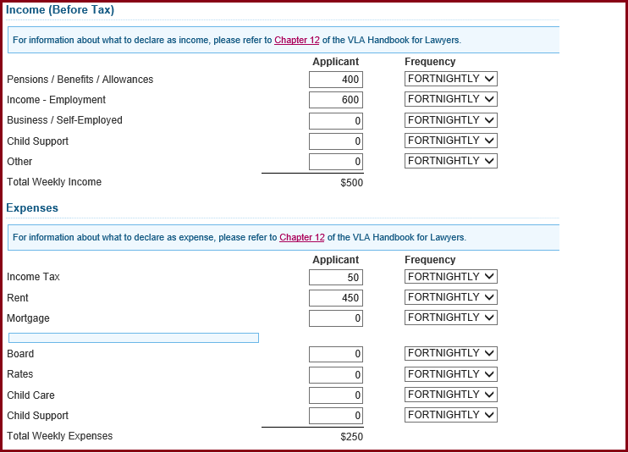
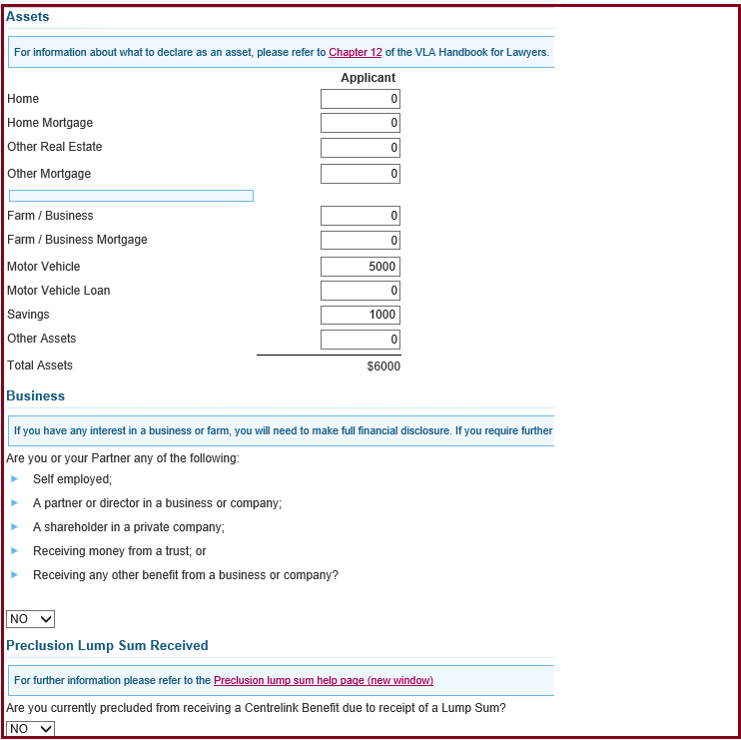
- The remaining sections of the application form are set out on the left-hand menu. The form is interactive, and certain questions are required or omitted dependent on information provided in other sections.
- Completed sections are marked with a green tick.
- Incomplete sections are marked with a red cross.
- Sections yet to be completed (or not needed to be completed) are marked with a blue arrow.

- Complete the Other Parties screen, if required. Select Add button to add another party and complete their details. If Other Parties screen is selected in error, delete by clicking on the x at the side of the screen and select OK to the warning message. To continue through to the next screen, select Next.
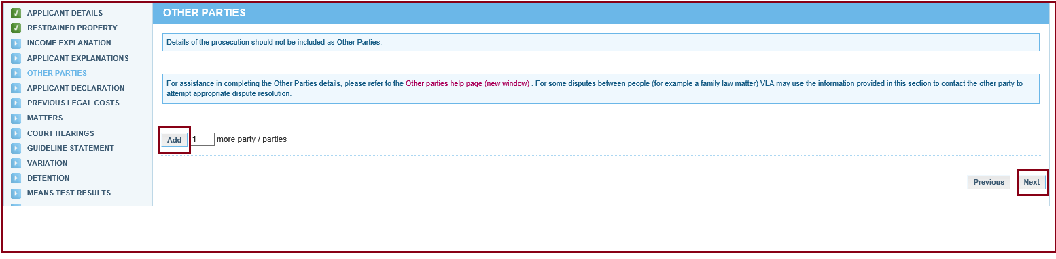
- The Applicant Declaration screen displays. Complete questions and enter the date the client signed the application. The electronic copy cannot be signed, however a completed application signed by the client needs to be kept on file. Without a signed legal aid application form or completed telephone authority declaration, an application cannot be submitted in ATLAS. Select Next.
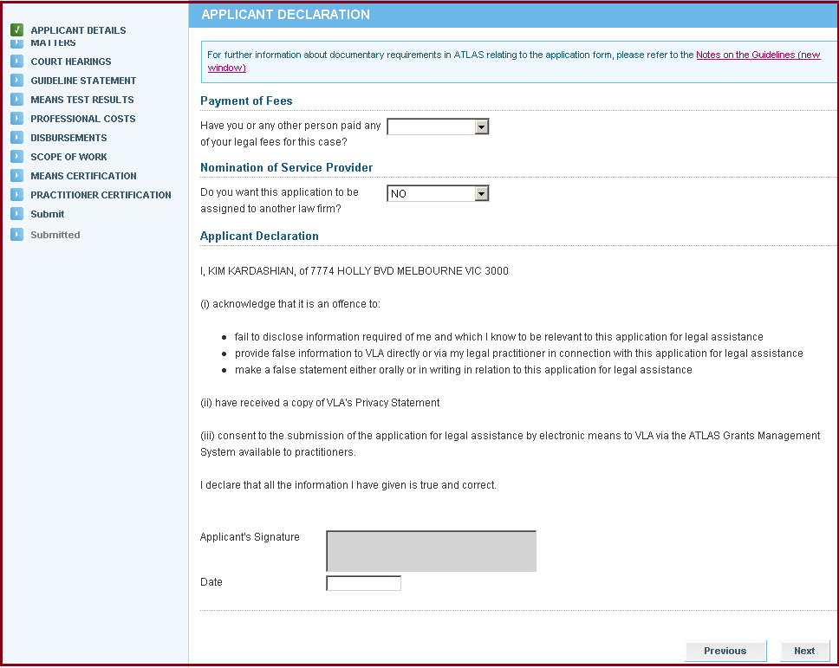
- The Matters screen displays. Add the matter by clicking on the drop-down arrow to select the Matter Group, then clicking on the drop-down arrow to select the appropriate Matter Type. Ensure the primary matter type is selected. The first matter entered will default to the primary matter. If additional matters are required then click Add, indicating how many more matters you need to add. Criminal law matters require the Plea to be selected for each Matter. Complete the CJEP/CAN field for each matter if available. Select Next.

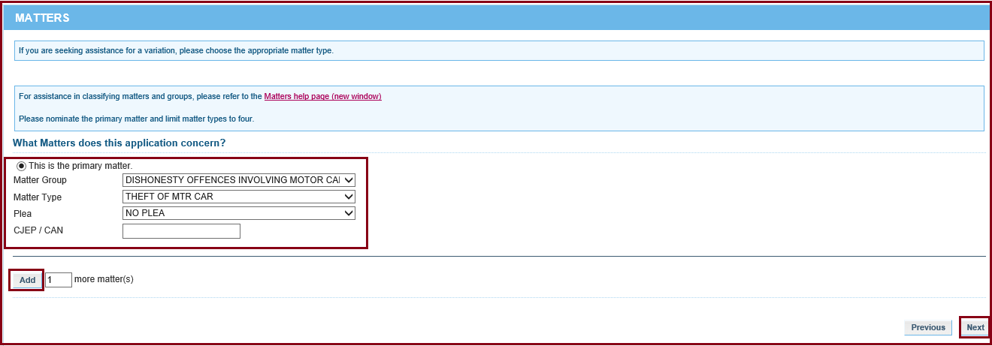
- The Court Hearings screen will display. Complete and select Next.
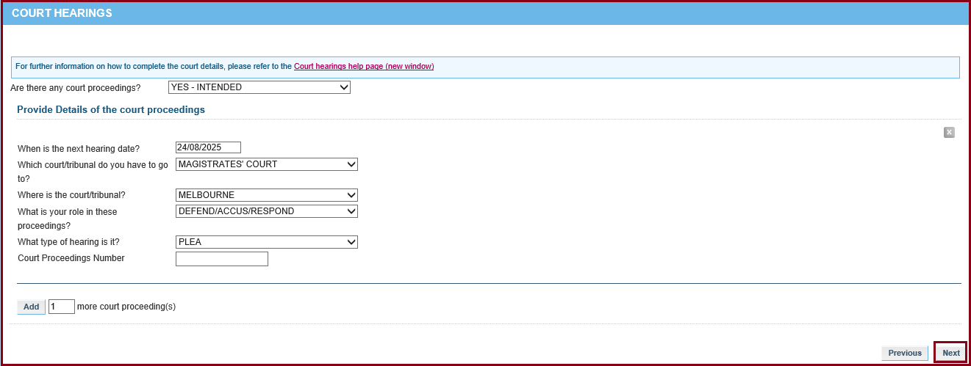
- The Guideline Statement screen will display. Choose the appropriate guideline that you are assessing the matter against and select Next.
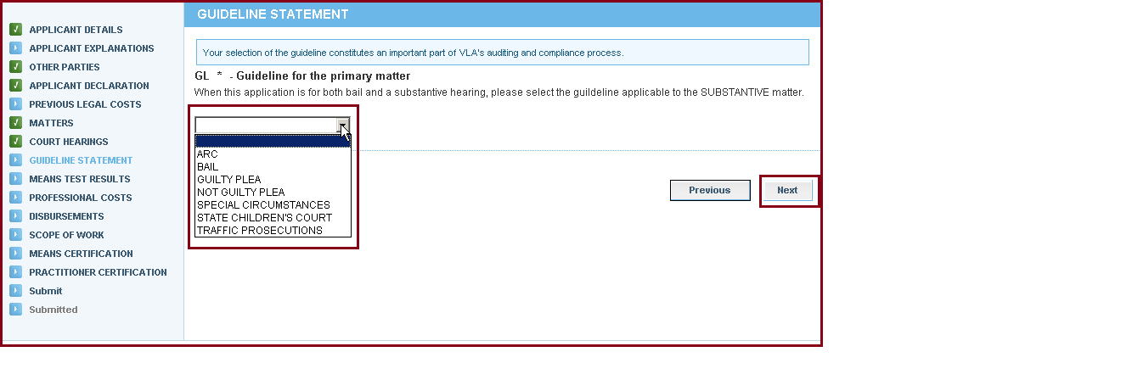
- The Additional Guideline Information screen will display. This forms part of the guidelines for Summary Crime matters only. Choose from the drop-down menus and tick boxes, the select Next.
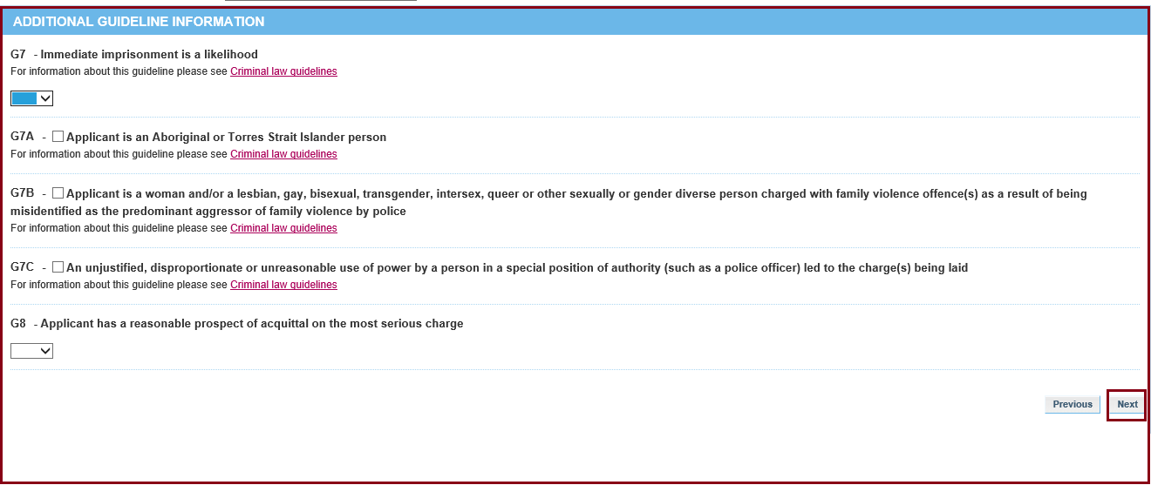
- The Means Test Results screen will display. The results are based on the information entered for the client. If your client is ineligible in income, assets or both or is required to pay a contribution, a ‘Request Discretion’ option will appear. If you choose Yes, then you need to provide reasons in the text box. Click Next.
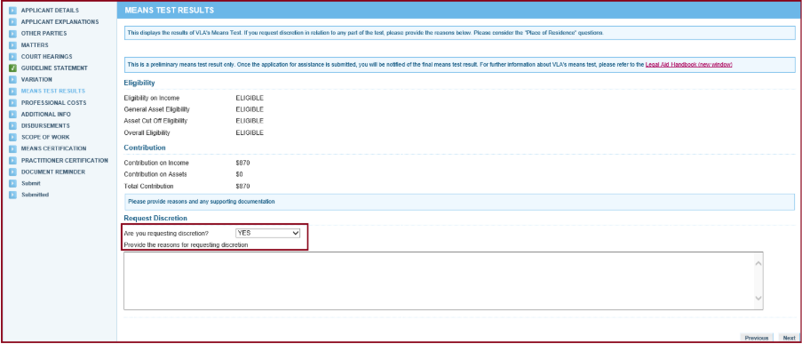
- The Professional Costs screen will display. This is where you can select the funding that you require at this stage of the legal matter. For summary crime matters, this can start with a ‘summary hearing lump sum’ or ‘consolidated hearing’ grant.
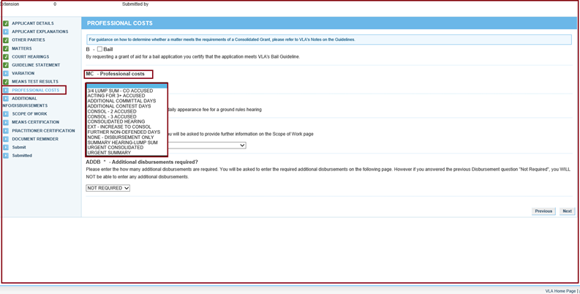
- Then choose from the Disbursement drop-down box (if required).
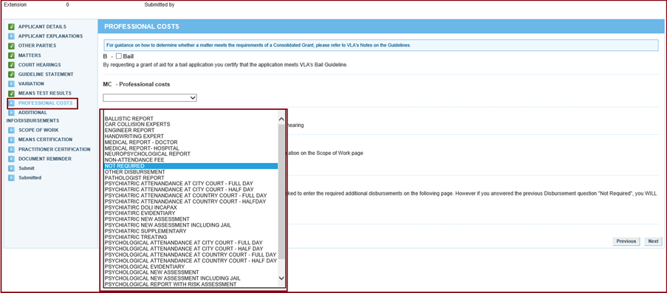
- Lastly, indicate any additional disbursements. Then click Next.
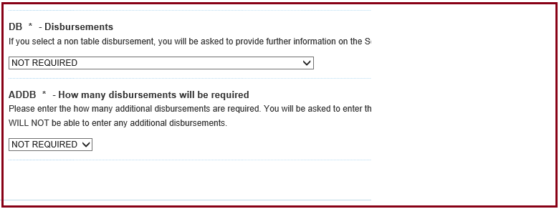
- The Scope of Work screen will appear. This is a summary of the fees that have been requested. Sometimes an explanation is required for disbursements.
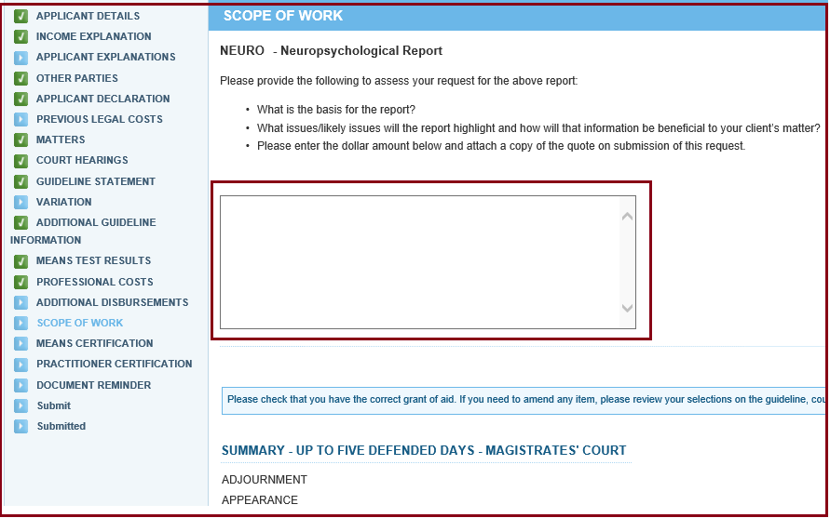
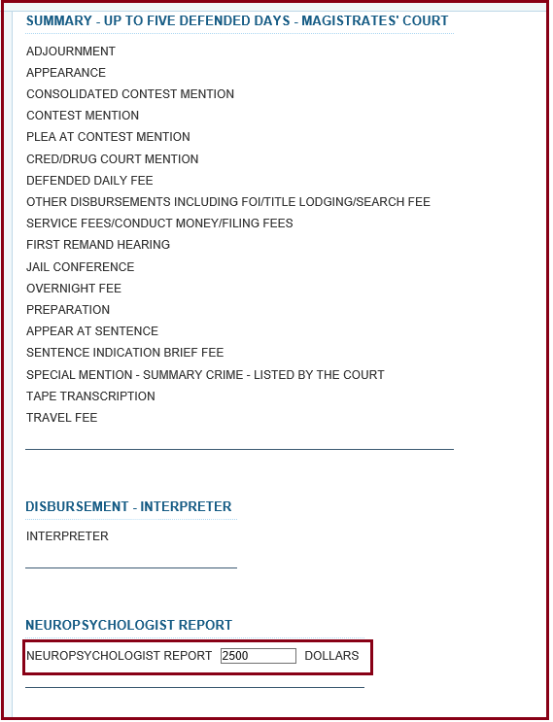
- The Means Certification screen is next. Select the appropriate certification and retain copies of proof of means on your file, if applicable. Select Next.
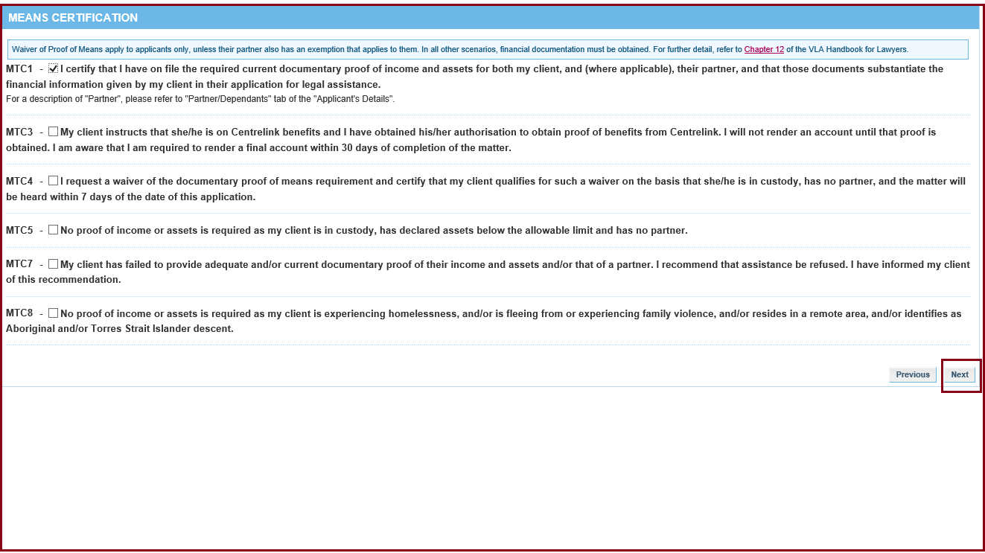
- The Practitioner Certification will display. Here the practitioner certifies that the application satisfies the applicable guideline and merits test. If the Certifier’s name does not appear on the screen, click the magnifying glass and choose the appropriate certifier. Fill in the Date and the Practitioner’s Reference. Click Next.
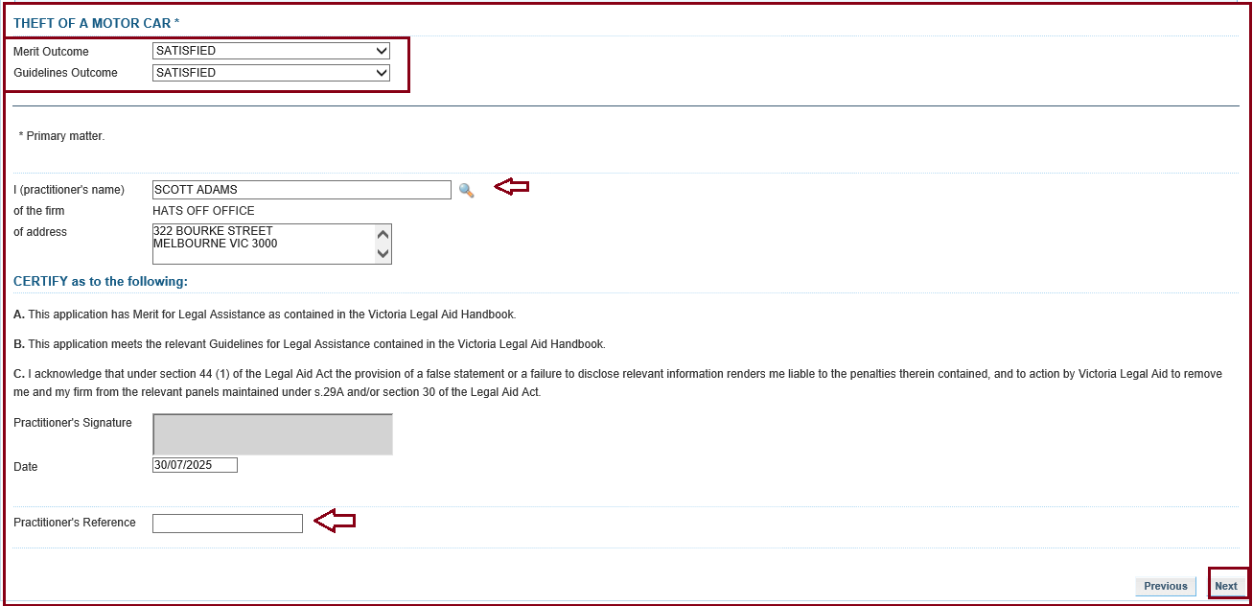
- The Document Reminder screen will display. Tick the box to confirm that you have all documentary requirements on file. If you need to attach any documents, you will be prompted to do so here, or you can do so using the Submit Correspondence in the ATLAS Menu.
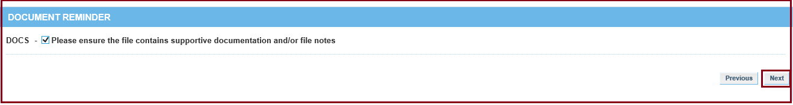
- The Submit screen will display. Select Submit to send it to Victoria Legal Aid for processing.
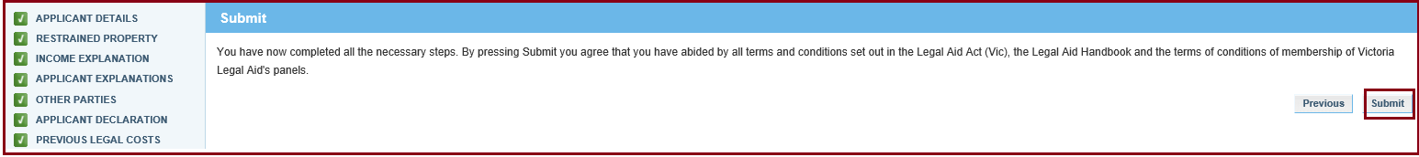
- You will get notification that the application was submitted successfully. Check your ATLAS inbox for a PDF of the completed application and the decision letter.
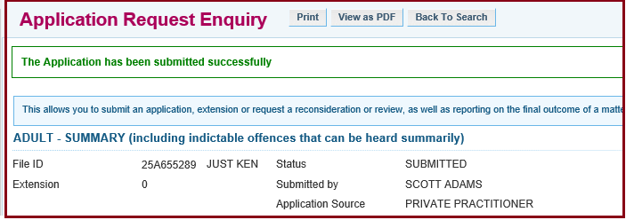

Additional Information:
- Practitioners are reminded that signed applications forms are declarations and therefore applicants must only sign the form once it is complete.
- The completed application signed by the client must be retained on the file.
- Victoria Legal Aid can only process an application that is submitted.
- Draft or saved applications cannot be processed.
- Draft applications are deleted from ATLAS after 90 days.

