This process guide has been prepared by our team of Practitioner Support Officers. If you have any access issues, or for any reason wish to contact Victoria Legal Aid about content on this page, please contact grantstraining@vla.vic.gov.au.

Update Client Details
If a client’s details change after an application for legal assistance has been submitted, use Update client details to notify VLA of the changes.
There is no need to send correspondence about these changes.

Steps:
- Click on the Update Client Details option from the left-hand menu under Client.
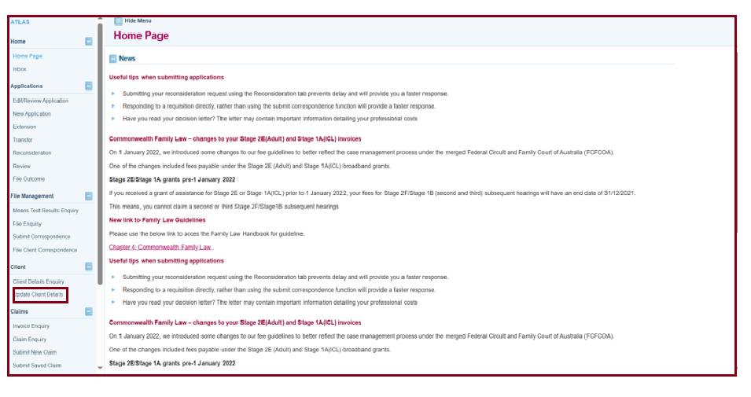
- The Client Update screen displays. Enter Client first name and Surname and select Search.
- Search Results will display. Click on the Client Name to retrieve the client.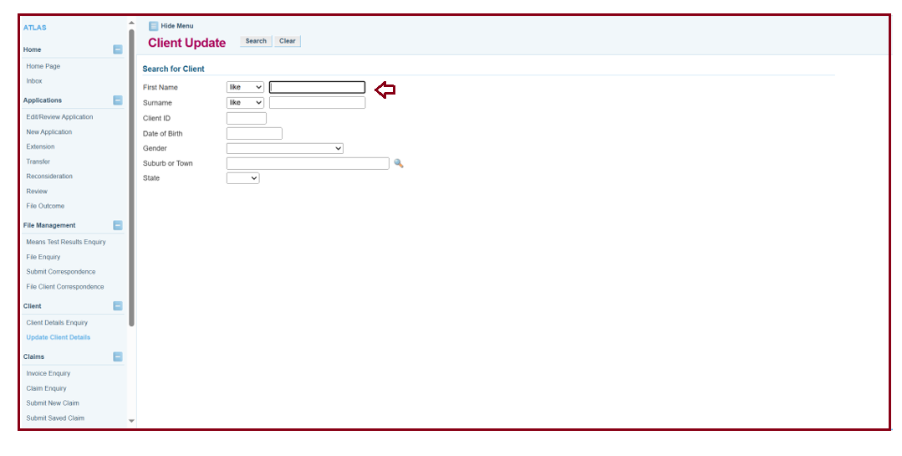

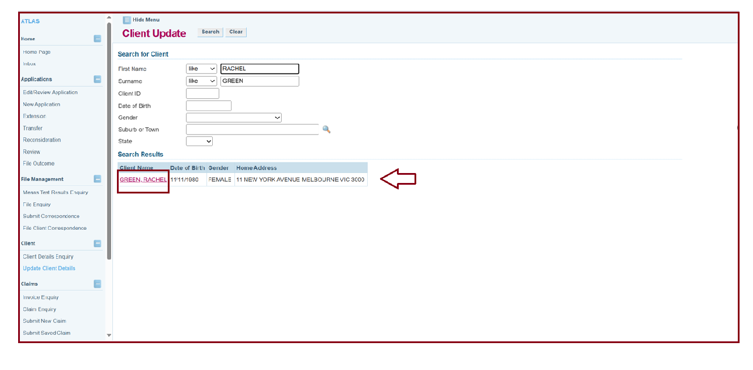
- The Update Client Details screen will display. Click on the relevant tab and update changes as required, such as:
- contact details such as address or telephone number
- additional details such as Centrelink benefit details
- income, expenses and asset details if the client’s financial circumstances have changed
- living arrangements.
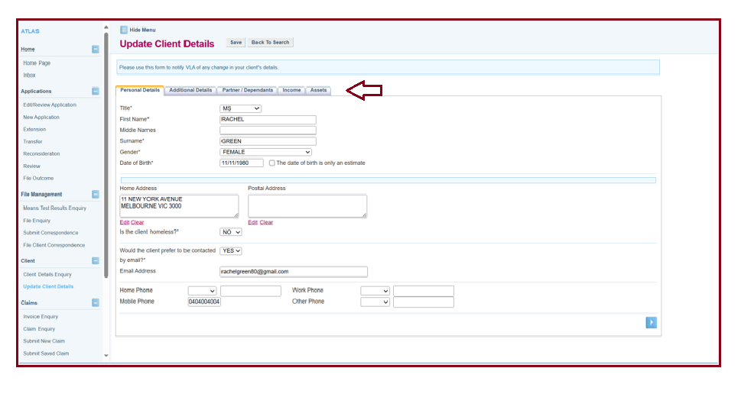
- Click on save once the relevant changes have been made.
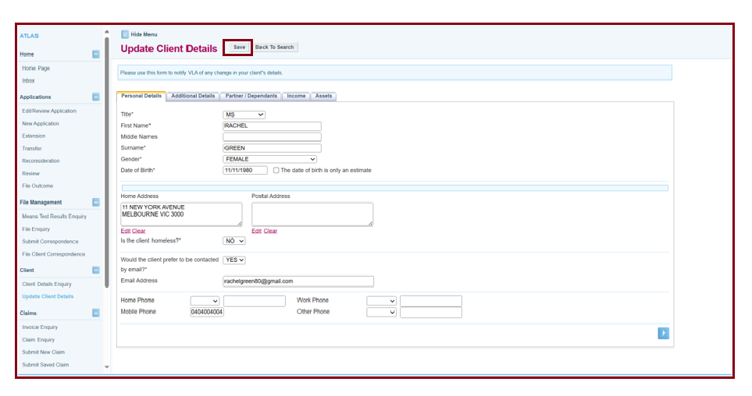
- A message will display in green that the changes have been saved successfully.
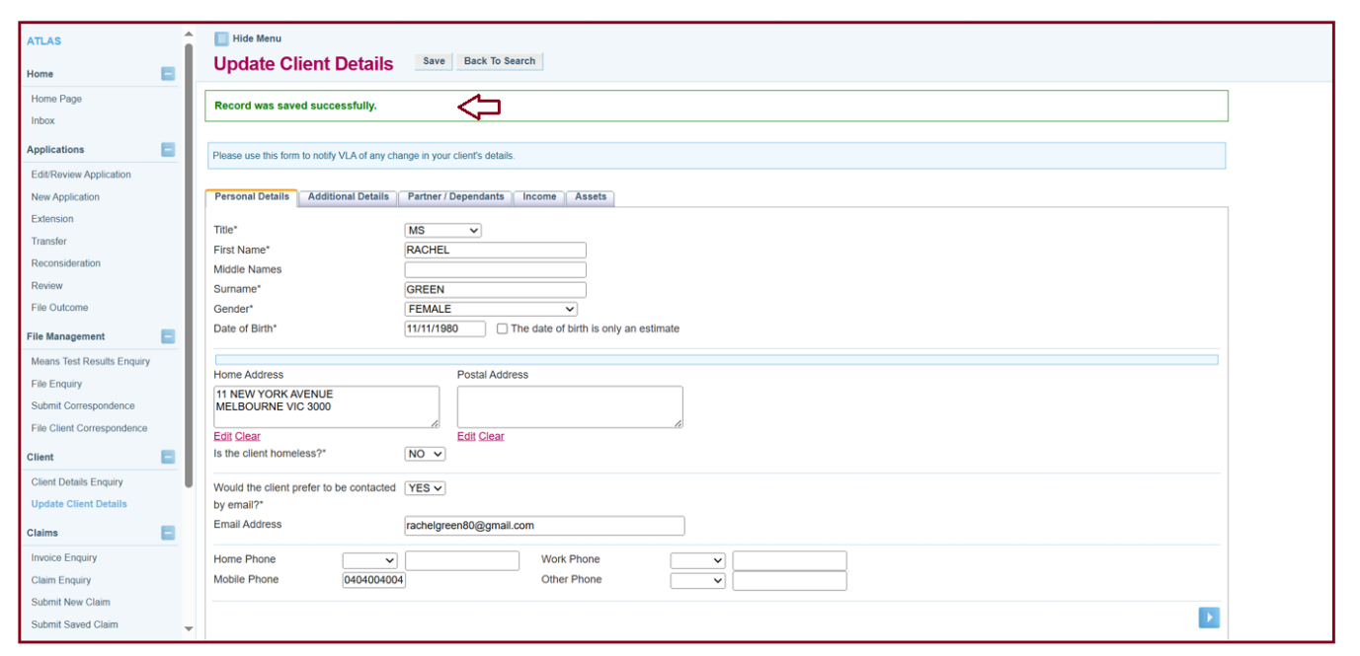
- If changes were made that relate to the client’s financial circumstances, there will be a warning notification that states that ATLAS will recalculate the means test for the client based on the new financial information provided. VLA will notify the client and their lawyer in writing if the grant of assistance is affected by the changes.
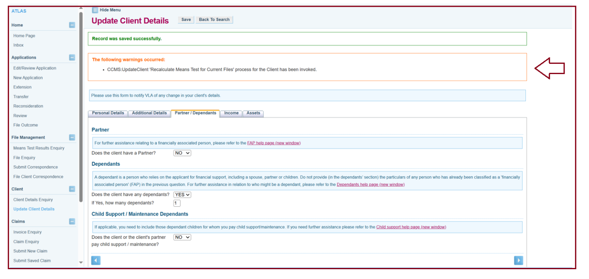

Additional Information:
- There is no need to send correspondence if the client’s details change. Using the Update Client Details is all you need to do.
- If you experience issues updating the client’s information, you can contact grants@vla.vic.gov.au and we can update them for you.

